William Faunce

Carol Roberts

COS 225

30 March 2018

A7WilliamFaunce

Part I

1. The result of mystery(3) is 25
2. d
3. 20 40 60 80
4. b
5. b
6. c
7. int power(int base, int exp) { PRE: base, exp >= 0 | POST: return base^exp

if(exp == 0)

return 1;

return (base \* power(base, exp-1));

}

Screenshots:

Run 1:

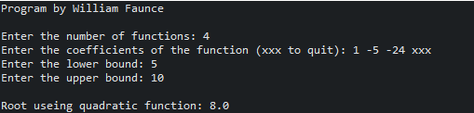

Run 2:

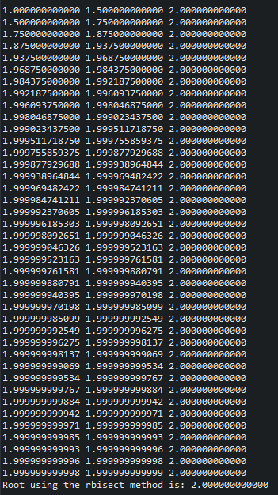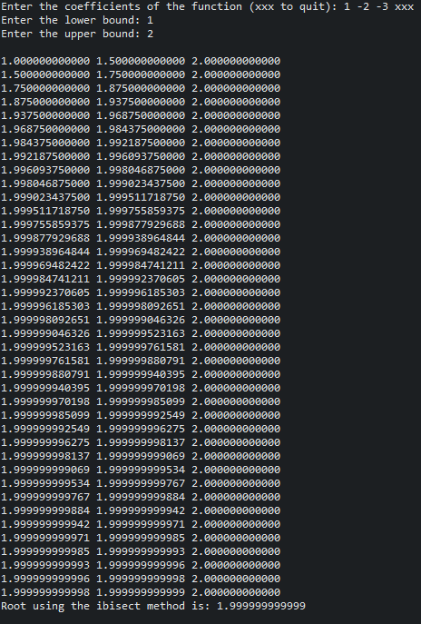

Run 3:

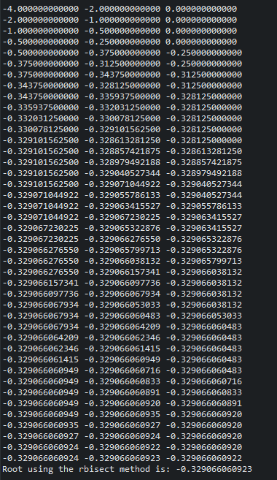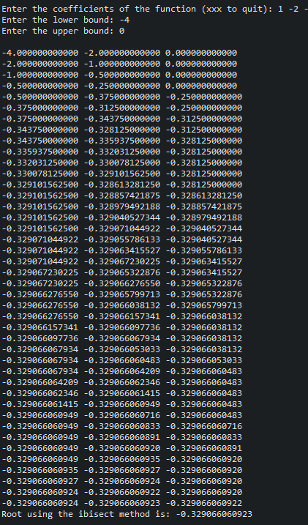

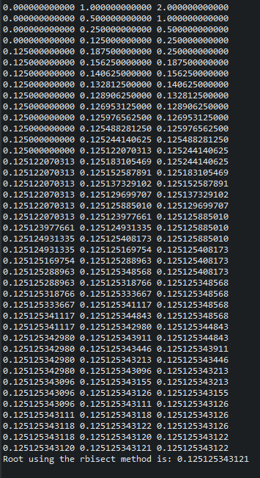Run 4:

